EBENEZER SECONDARY AND VOCATIONAL SCHOOL MUTUNGO

END OF TERM 1 2024

**S.2 BIOLOGY**

**2 HOURS**

**Instructions**

* **Answer all questions**

**Item 1**

Ministry of Health (MoH) NOTED that of recent there disease that have emerged and have no cure. Some of them have killed many people all over the world and the World Health Organization (WHO) has declared them pandemic. On further investigations, the MoH discovered that these diseases have been identified World wide. Among these include: HIV , Ebola, Hepatitis B and of recent, COVID-19. Many communities in our society are not aware of the causes and how these diseases are transmitted, their symptoms and prevention.

SUPPORT MATERIAL

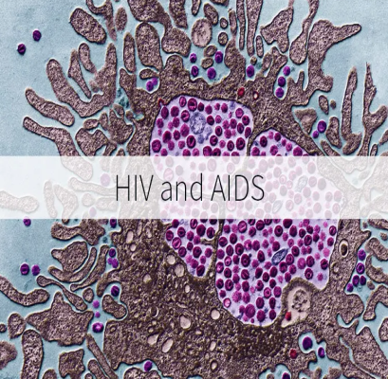 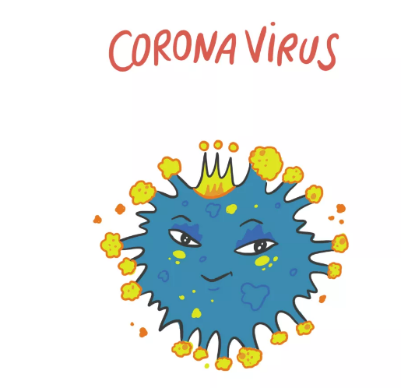

Task.

If the Ministry of Health appoints you as one of the people to sensitize the community about these diseases.

Design a message you would use to inform the community on the causes, transmission, symptoms and prevention of these viral diseases so that they are not widely spread in the communities. (10 scores).

……………………………………………………………………………………………………………………………………………………………………………………………………………………………………………………………………………………………………………………………………………………………………………………………………………………………………………………………………………………………………………………………………………………………………………………………………………………………………………………………………………………………………………………………………………………………………………………………………………………………………………………………………………………………………………………………………………………………………………………………………………………………………………………………………………………………………………………………………………………………………………………………………………………………………………………………………………………………………………………………………………………………………………………………………………………………………………………………………………………………………………………………………………………………………………………………………………………………………………………………………………………………………………………………………………………………………………………………………………………………………………………………………………………………………………………………………………………………………………………………………………………………………………………………………………………………………………………………………………………………………………………………………………………………………………………………………………………………………………………………………………………………………………………………………………………………………………………………………………………………………………………………………………………………………………………………………………………………………………………………………………………………………………………………………………………………………………………………………………………………………………………………………………………………………………………………………………………………………………………………………………………………………………………………………………………………………………………………………………………………………………………………………………………………………………………………………………………………………………………………………………………………………………………………………………………………………………………………………………………………………………………………………………………………………………………………………………………………………………………………………………………………………………………………………………………………………………………………………………………………………………………………………………………………………………………………………………………………………………………………………………………………………………………………………………………………………………………………………………………………………………………………………………………………………………………………………………………………………………………………………………………………………………………………………

Item 2

Okello lives in the suburbs of Kampala city near Wandegeya in Katanga village. His house is bordering a water drainage channel that floods with sewage, especially during rainy seasons. One day , he noticed that in the water channel there were many mosquito larvae and that is why he was suffering from malaria time and again. His neighbor, Mukasa , had also created a rubbish pit in front of his house besides the water channel where jack fruit and banana peels were dumped regularly. These attracted many houseflies that fed on rotting organic matter .The houseflies visited their houses and at times rested on their cold food that was left exposed which later would be eaten. During rainy seasons, his family members would experience diseases like malaria, dysentery and cholera occasionally.

Besides the water channel opposite his house, Okello had a maize garden there. As he was wedding his maize plants, he noticed that army worms (caterpillars) were destroying the shoots of his maize. He as well found out that some maize plants were being destroyed by termites from the nearby anthill. He became so disappointed and didn’t know to do next

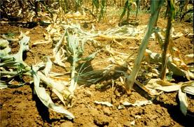

**Task.**

1. As a student who has studied about insects, what advice can you give to Okello who lives in Katanga village to overcome the challenges is facing**.(10scores)**

................................................................................................................................................................................................................................................................................................................................................................................................................................................................................................................................................................................................................................................................................................................................................................................................................................................................................................................................................................................................................................................................................................................................................................................................................................................................................................................................................................................................................................................................................................................................................................................................................................................................................................................................................................................................................................................................................................................................................................................................................................................................................................................................................................................................................................................................................................................................................................................................................................................................................................................................................................................................................................................................................................................................................................................................................................................................................................................................................................................................................................................................................................................................................................................................................................................................................................................................................................................................................................................................................................................................................................................................................................................................................................................................................................................................................................................................................................................................................................................................................................................

1. Using observable features, construct a dichotomous key to identify the insects disturbing Okello of Katanga village.(**5 scores)**

……………………………………………………………………………………………………………………………………………………………………………………………………………………………………………………………………………………………………………………………………………………………………………………………………………………………………………………………………………………………………………………………………………………………………………………………………………………………………………………………………………………………………………………………………………………………………………………………………………………………………………………………………………………………………………………………………………………………………………………………………………………………………………………………………………………………………………………………………………………………………………………………………………………………………………………………………………………………………………………………………………………………………………………………………………………………………………………………………………………………………………………………………………………………………………………………………………………………………………………………………….....................................

PART II

ITEM 3

Justine , a youth living living in Rwemikona in Mbarara city, dropped out of school before completing primary seven due to lack of school fees. She was wondering what type of business she could start inorder to earn a living.

Her friend Mercy proposed to her to start a business of growing ornamental plants at the banks of River Rwizi . She secured a place for her where she could grow her plants and gave her capital of 150,000 Uganda shillings to start with. Justine was very happy with her friend’s idea and the support. However , she has no idea of how to start the business and the types of plants to stock that would have attractive features to her customers to buy so that they plant them in their compounds or use them for decorative purposes.

**SUPPORT MATERIAL**

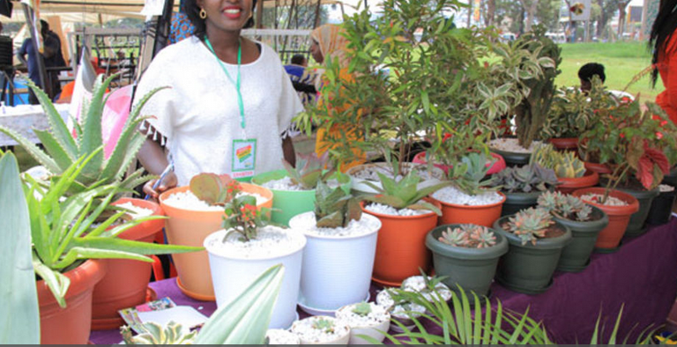

**TASK**

As a biology student who has studied a topic about structures of flowering plants, write an article to Justine that would enable her stock plants with attractive features to impress her customers to buy ornamental plants**.(20 SCORES)**

**ITEM 4**

The people in your community have a challenge of deficiency diseases. You have been selected by your class teacher to represent your class on a sensitization campaign to help those people overcome the diseases.

**SUPPORT MATERIAL**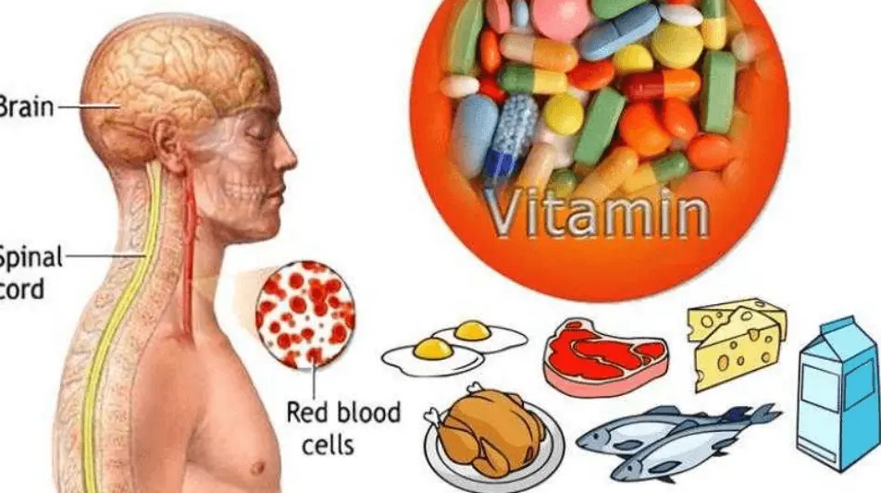

**TASK.**

Prepare a poster you will use to sensitize the people in your community on how to overcome the deficiency diseases.(20 scores)

**ITEM 5**

Obesity is the most common nutritional disorder in industrialized countries . It is also becoming increasingly prevalent in developing countries like Uganda due to changing lifestyles like eating junk foods which contain very high colories and dormant/inactive life styles. Besides that there are other related disorders like Bulimia and Anorexia.

**SUPPORT MATERIAL**

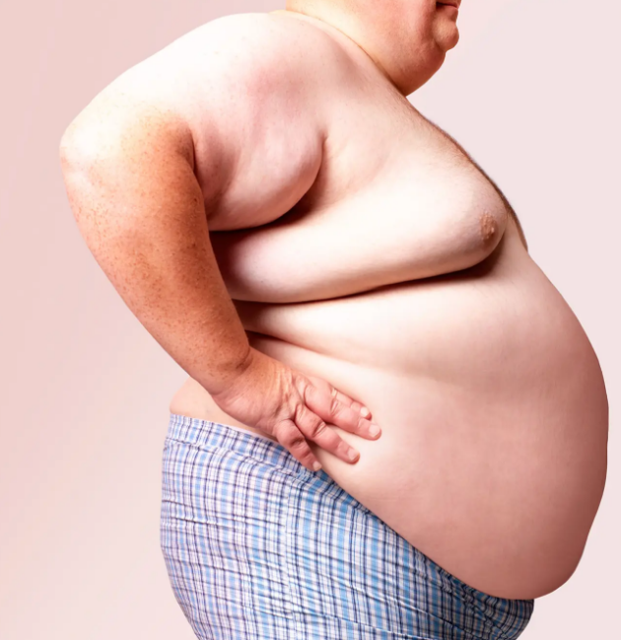 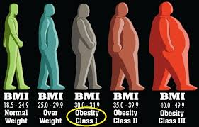

**TASK**

Using your knowledge of Body mass Index, advice the people in the community about the effects of Bulimia, obesity and anorexia **(.20scores)**

**END**

**NO SWEAT, NO SUCCESS**